Diagonal
# Source: AI Source: Provided by: [Data Path: Persons Table -> ID Column: 1, Name_En Column: Motasem Essam] -> From: [ChatGPT] on [7/25/2026]
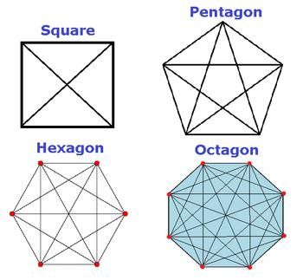
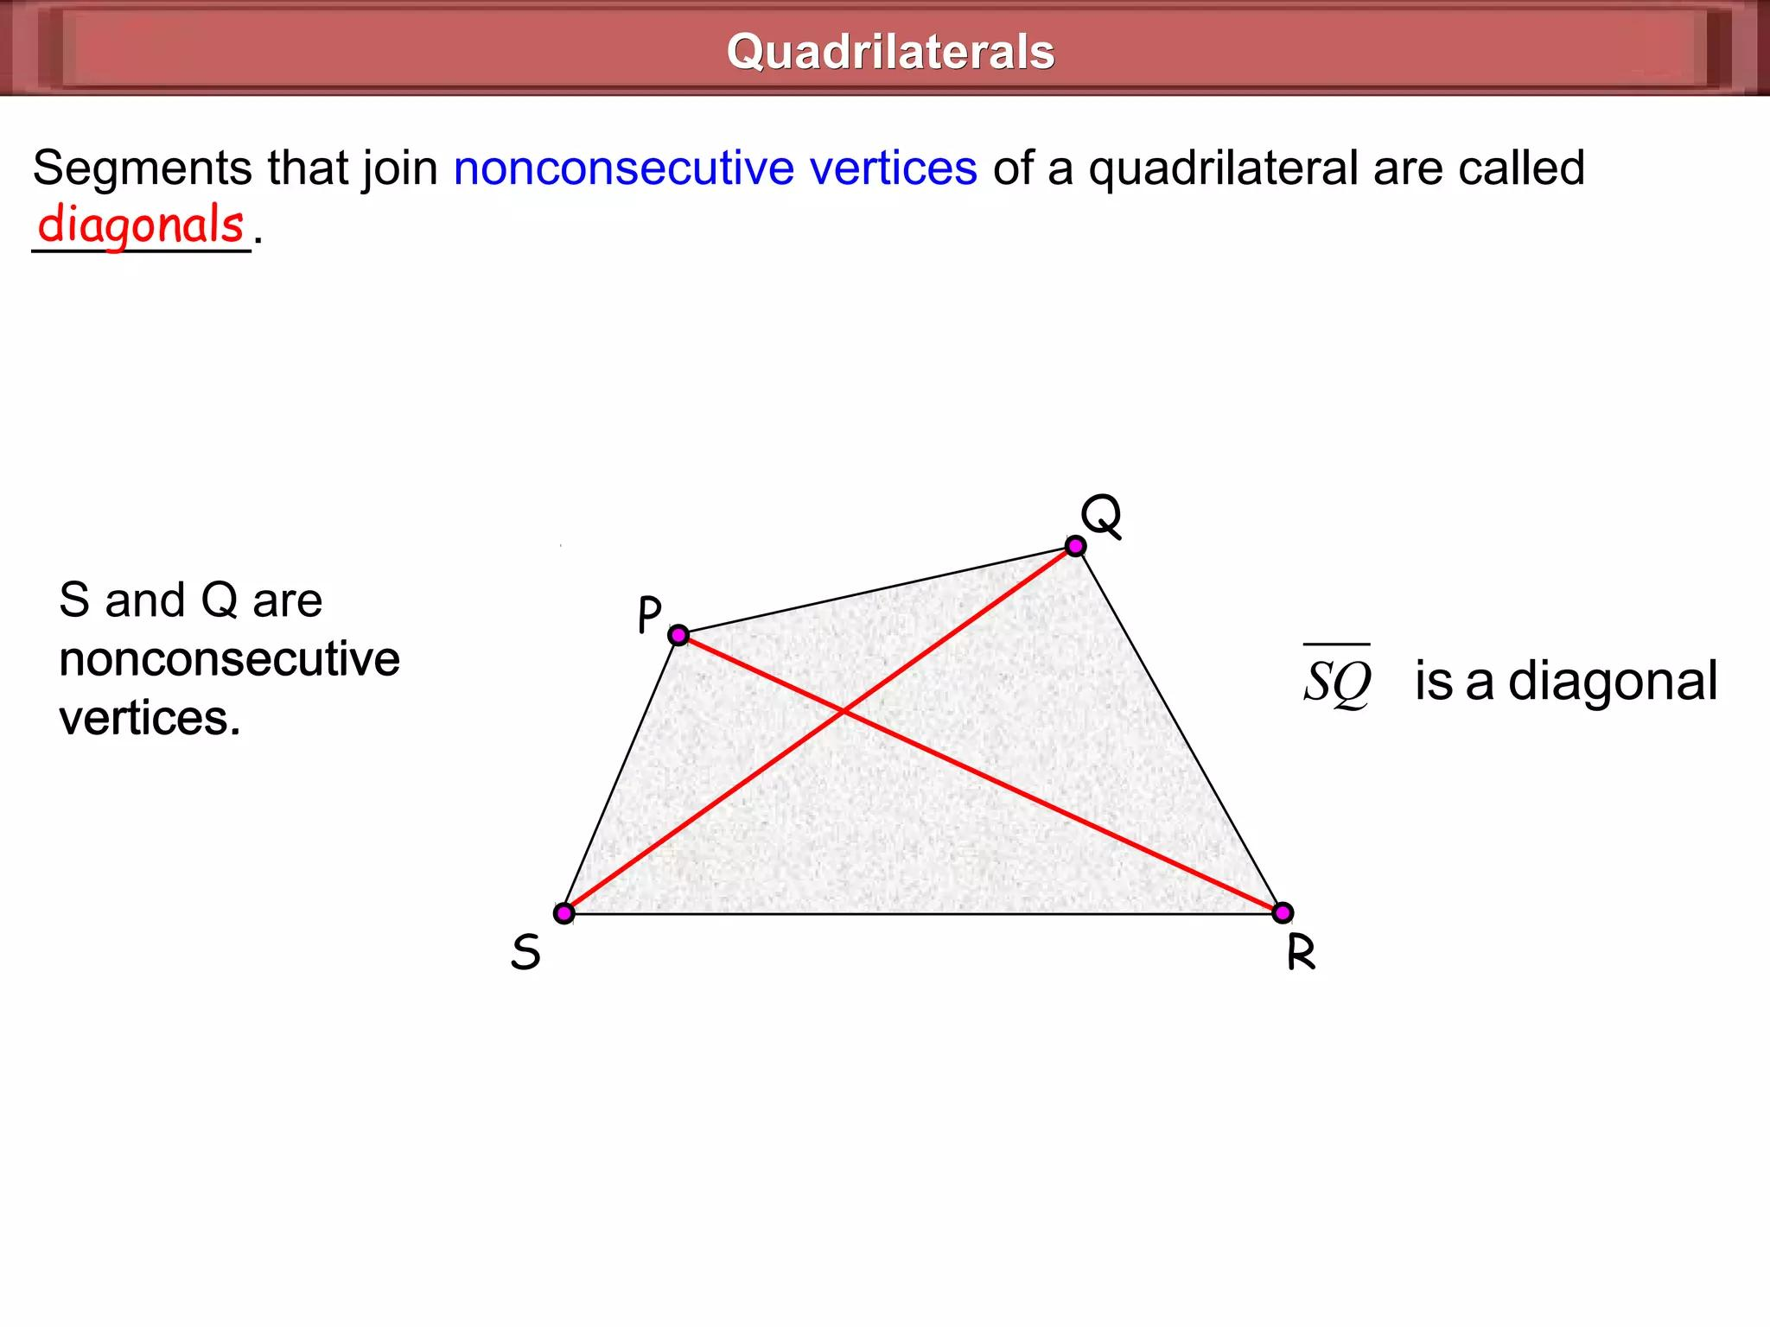
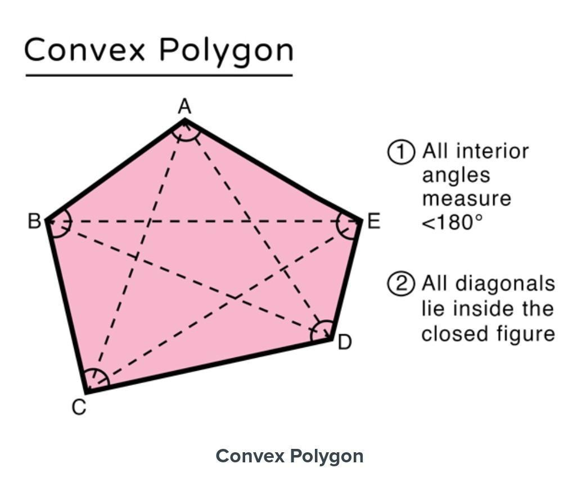
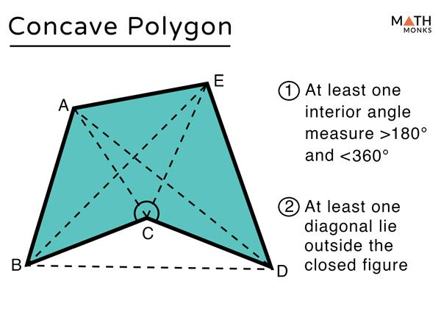
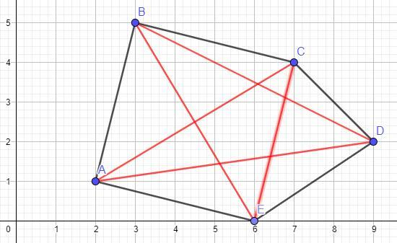
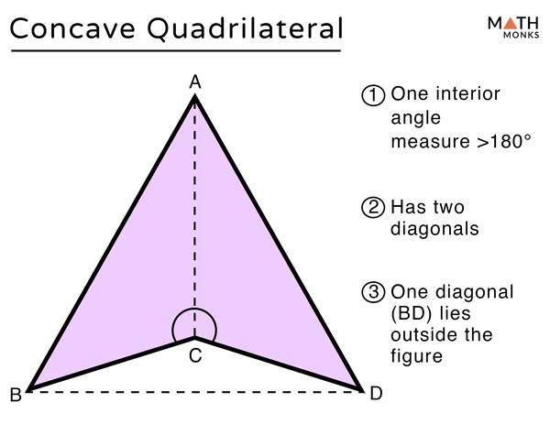

Definition
# Source: AI Source: Provided by: [Data Path: Persons Table -> ID Column: 1, Name_En Column: Motasem Essam] -> From: [ChatGPT] on [7/25/2026]
A Diagonal in plane geometry is a line segment that connects two non-adjacent vertices of a polygon.
A diagonal:
- Starts at one vertex.
- Ends at another vertex.
- Does not lie along the boundary of the polygon.
- Connects vertices that are not directly connected by a side.

Illustration
# Source: AI Source: Provided by: [Data Path: Persons Table -> ID Column: 1, Name_En Column: Motasem Essam] -> From: [ChatGPT] on [7/25/2026]
Square Diagonal
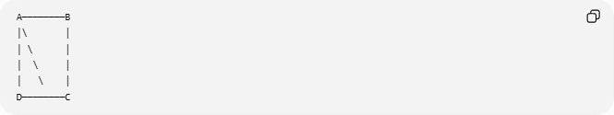
A────────B
│\ │
│ \ │
│ \ │
│ \ │
D────────C
The segment:
$$\overline{AC}$$
is a diagonal because:
- A and C are vertices.
- They are not connected by a side.

Characteristics of a Diagonal
# Source: AI Source: Provided by: [Data Path: Persons Table -> ID Column: 1, Name_En Column: Motasem Essam] -> From: [ChatGPT] on [7/25/2026]
A diagonal:
- Exists only in polygons.
- Connects two non-consecutive vertices.
- Is a line segment.
- Lies inside a convex polygon.
- May lie outside a concave polygon.
- Divides a polygon into smaller polygons.

Mathematical Representation
# Source: AI Source: Provided by: [Data Path: Persons Table -> ID Column: 1, Name_En Column: Motasem Essam] -> From: [ChatGPT] on [7/25/2026]
If a polygon has vertices:
$$P_{1},P_{2},P_{3},…,P_{n}$$
a diagonal is:
$$\overline{P_{i}P_{j}}$$
where:
$$\left|i-j\right|≠1$$
and the vertices are not adjacent.

Number of Diagonals in a Polygon
# Source: AI Source: Provided by: [Data Path: Persons Table -> ID Column: 1, Name_En Column: Motasem Essam] -> From: [ChatGPT] on [7/25/2026]
For a polygon with:
$$n$$
sides, the number of diagonals is:
$$\boxed{\frac{n\left(n-3\right)}{2}}$$

Examples
# Source: AI Source: Provided by: [Data Path: Persons Table -> ID Column: 1, Name_En Column: Motasem Essam] -> From: [ChatGPT] on [7/25/2026]
Triangle

A
/ \
/ \
B─────C
Number of diagonals:
$$\frac{3\left(3-3\right)}{2}=0$$
A triangle has no diagonals because every vertex is already connected by sides.

Quadrilateral

A────────B
│\ /│
│ \ / │
│ \ / │
D────────C
Diagonals:
$$\overline{AC} \\ \overline{BD}$$
Number:
$$\frac{4\left(4-3\right)}{2}=2$$

Pentagon

A
/ \
E B
| |
D─────C
Number of diagonals:
$$\frac{5\left(5-3\right)}{2}=5$$

Diagonals in Different Shapes
# Source: AI Source: Provided by: [Data Path: Persons Table -> ID Column: 1, Name_En Column: Motasem Essam] -> From: [ChatGPT] on [7/25/2026]
Convex Polygon
In a convex polygon:
- All diagonals remain inside the shape.
Example:

______
/ \
/________\

Concave Polygon
In a concave polygon:
- Some diagonals may pass outside the polygon.
Example:

______
/ /
| ___/
| /

Diagonal Properties
# Source: AI Source: Provided by: [Data Path: Persons Table -> ID Column: 1, Name_En Column: Motasem Essam] -> From: [ChatGPT] on [7/25/2026]
1. Divides Polygon into Triangles
A diagonal from one vertex divides a polygon into triangles.
Example:
Pentagon:
$$5-2=3$$
It can be divided into:
$$3$$
triangles.

2. Length of a Rectangle Diagonal
For a rectangle:
$$d=\sqrt{l^{2}+w^{2}}$$
where:
- $l$ = length
- $w$ = width

3. Square Diagonal
For a square:
$$d=s\sqrt{2}$$
where:
- $s$ = side length

Diagonal vs Side
# Source: AI Source: Provided by: [Data Path: Persons Table -> ID Column: 1, Name_En Column: Motasem Essam] -> From: [ChatGPT] on [7/25/2026]
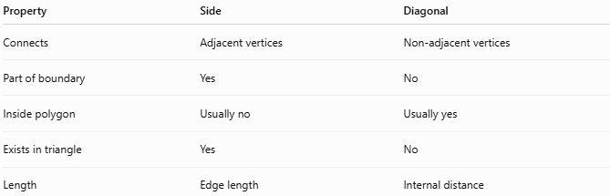
Property | Side | Diagonal
Connects | Adjacent vertices | Non-adjacent vertices
Part of boundary | Yes | No
Inside polygon | Usually no | Usually yes
Exists in triangle | Yes | No
Length | Edge length | Internal distance

Real-World Examples
# Source: AI Source: Provided by: [Data Path: Persons Table -> ID Column: 1, Name_En Column: Motasem Essam] -> From: [ChatGPT] on [7/25/2026]
Diagonals appear in:
- Building frames.
- Bridges.
- Roof structures.
- Screens and displays.
- Maps.
- Engineering designs.
- Computer graphics.
- Polygon modeling.

Applications
# Source: AI Source: Provided by: [Data Path: Persons Table -> ID Column: 1, Name_En Column: Motasem Essam] -> From: [ChatGPT] on [7/25/2026]
Diagonals are important in:
- Plane Geometry
- Polygon Theory
- Coordinate Geometry
- Trigonometry
- Architecture
- Engineering
- CAD Design
- Computer Graphics
- Robotics

Advantages
# Source: AI Source: Provided by: [Data Path: Persons Table -> ID Column: 1, Name_En Column: Motasem Essam] -> From: [ChatGPT] on [7/25/2026]
Studying diagonals helps to:
- Calculate distances inside shapes.
- Divide polygons into triangles.
- Find areas of complex polygons.
- Analyze structural strength.
- Understand polygon properties.

Limitations
# Source: AI Source: Provided by: [Data Path: Persons Table -> ID Column: 1, Name_En Column: Motasem Essam] -> From: [ChatGPT] on [7/25/2026]
Diagonals:
- Exist only in polygons.
- Do not apply to open shapes.
- May become complex in large polygons.
- Can extend outside concave polygons.

Key Points
# Source: AI Source: Provided by: [Data Path: Persons Table -> ID Column: 1, Name_En Column: Motasem Essam] -> From: [ChatGPT] on [7/25/2026]
- A Diagonal is a line segment connecting two non-adjacent vertices of a polygon.
- Triangles have:
$$0$$
diagonals.
- A polygon with (n) sides has:
$$\frac{n\left(n-3\right)}{2}$$
diagonals.
- Diagonals divide polygons into smaller triangles.
- They are fundamental tools in geometry and design.

Conclusion
# Source: AI Source: Provided by: [Data Path: Persons Table -> ID Column: 1, Name_En Column: Motasem Essam] -> From: [ChatGPT] on [7/25/2026]
A Diagonal is a line segment inside a polygon that connects two non-adjacent vertices. It is different from a side because it does not form part of the polygon boundary. Diagonals are essential in plane geometry, polygon analysis, coordinate geometry, architecture, engineering, CAD, and computer graphics, where they are used to calculate distances, divide shapes, determine areas, and analyze geometric structures.

